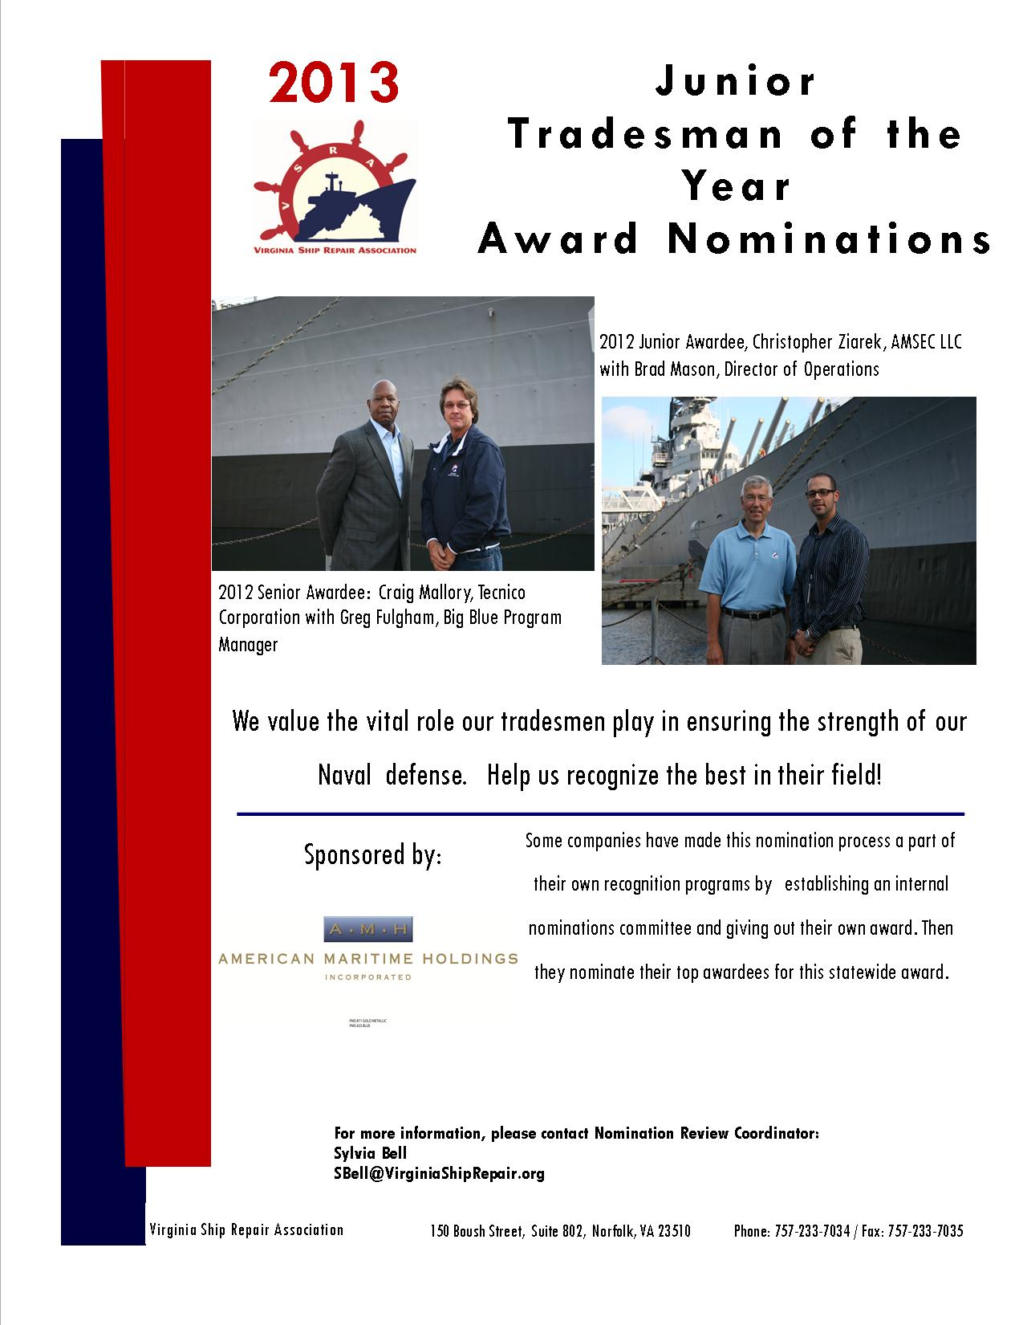

Virginia Ship Repair Foundation
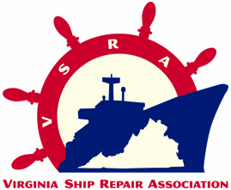
2013 JUNIOR TRADESMAN OF THE YEAR
(Less than five years in trade)
NOMINATION FORM
Only ONE Jr. Nominee per company. INCOMPLETE NOMINATIONS WILL NOT BE CONSIDERED.
Company Submitting Nomination:_____________ VSRA Member? YES☐ NO☐
Nominee’s Name: _______________________________________________________
Nominee’s Trade Area: ______________ Less than 5 years in trade? YES☐ NO☐
(Note: This is total experience regardless of company affiliation)
Nominee’s Current Job Title: _________________Jacket Size: Choose an item.
Nominee’s Telephone Number: ____________________________
Nominator’s Name: _________________ Nominator’s Job Title: ____________________
Email: ______________________ Nominator’s Telephone Number: ____
Please list the last three employments with company name, job title, and duration of employment:
 | Company | Job Title | Duration of Employment
1. | Click here to enter text. | Click here to enter text. | Click here to enter text.
2. | Click here to enter text. | Click here to enter text. | Click here to enter text.
3. | Click here to enter text. | Click here to enter text. | Click here to enter text.
You may submit your nomination in one of three ways: email, fax, or mail. Send to: Sylvia Bell at fax 757.233.7035 or SBell@VirginiaShipRepair.org; or 150 W. Boush Street, Suite 802 Norfolk, VA 23510. Please submit your typewritten nomination entry, along with this form by Friday April 26, 2013 at 5:00 p.m. NO EXTENSIONS will be made on the deadline! If you have any questions please contact the Nomination Review Coordinator: Sylvia Bell at SBell@VirginiaShipRepair.org
- Please COMMENT on performance for each standard.
1. Demonstrates proficiency in area of expertise. | Click here to enter text.
2. Consistently performs at the highest level of quality. | Click here to enter text.
3. Consistently shares expertise with less experienced co-workers. | Click here to enter text.
4. Mentors less experienced workers on career development plans. | Click here to enter text.
5. Shares feedback on improvements with supervisors. | Click here to enter text.
6. Seeks training and improvement opportunities to enhance trade and operational expertise. | Click here to enter text.
7. Maintains an exemplary safety record. | Click here to enter text.
8. Instills safe working practices in co-workers/team. | Click here to enter text.

CRITERION I. PROFESSIONAL REPRESENTATION OF THE SHIP REPAIR INDUSTRY
NOTE: This is the most important part of the scoring! You must describe how this nominee has EXCELLED in their field.
Briefly describe how the nominee demonstrates proficiency and excellence in his/her job:
Click here to enter text.

Please respond with SPECIFIC EXAMPLES for each question.
Provide an example of creativity or innovation on the job:
Click here to enter text.

Provide an example of leadership, mentorship or role modeling:
(Note: This topic often results in more points and distinguishes future experts from the group)
Click here to enter text.

Provide an example of how the person has been recognized by the company, customers or other organizations:
Click here to enter text.

Provide an example of Professional Development achievements (i.e. certifications, training, specialized skills)
Click here to enter text.

Provide an example of Community Leadership Achievements
Click here to enter text.

COMPANY AWARD AGREEMENT
- Per a decision by the Virginia Ship Repair Foundation, the awardee category will receive a VSRA embroidered jacket, $500.00 and awards. In addition, the company submitting this nomination form agrees to give the nominee time to attend the VSRA General Membership Luncheon on Tuesday May 21, 2013 where the winner will be announced and if the employee is the winner time to attend the Annual National Maritime Day Reception. The company may decide, at their discretion, to allow the paid day off and allow the employee to attend the luncheon on a regularly scheduled work day. Nominees may bring one guest of their choosing to each of the events; companies cover additional seats at their expense.

Authorizing Company Representative Signature Date

