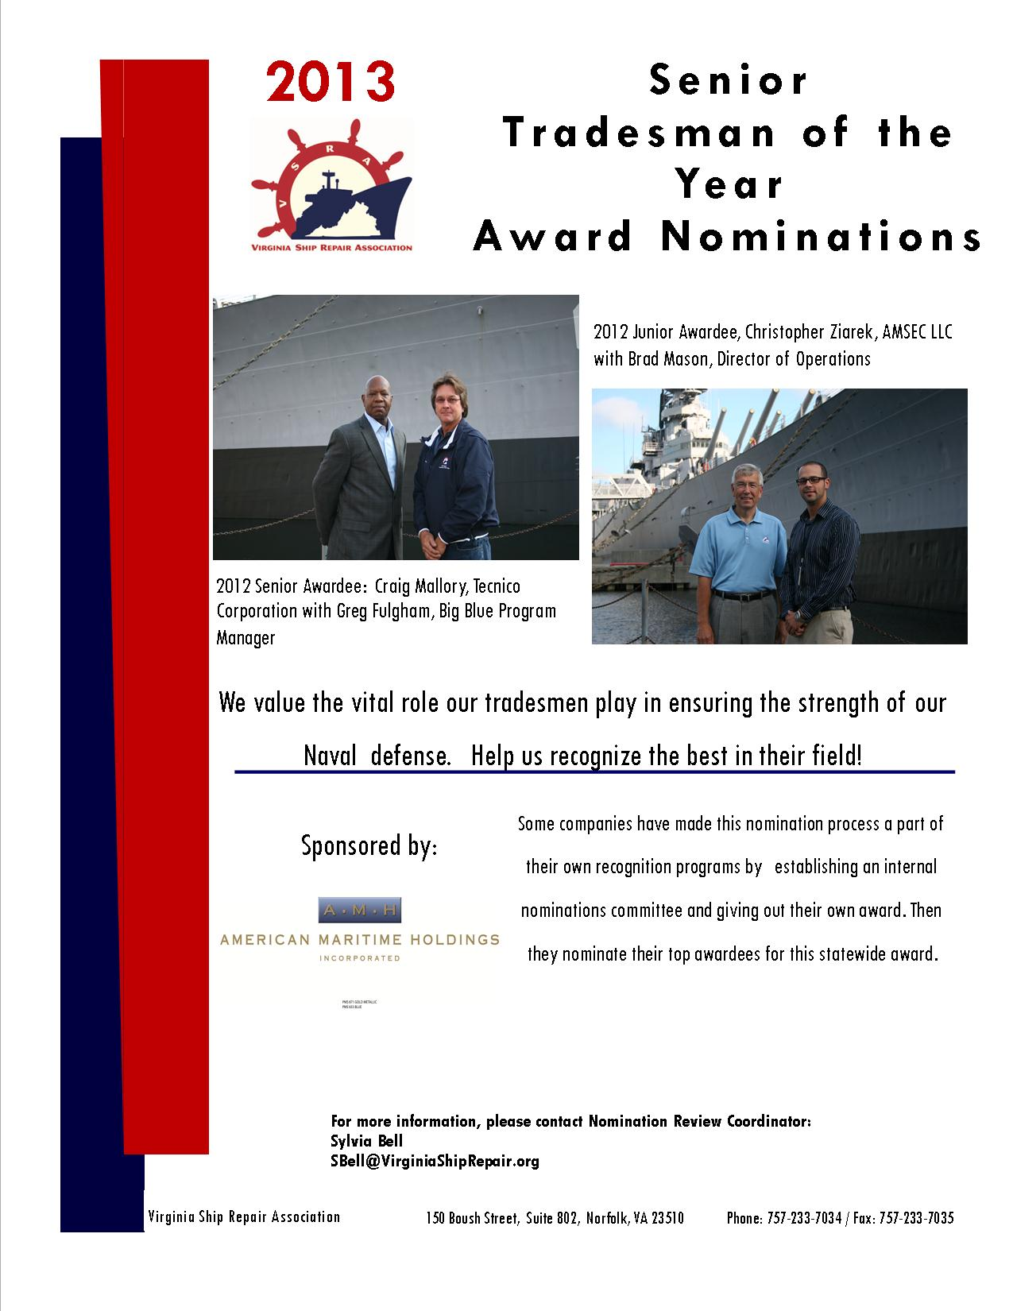

Virginia Ship Repair Foundation
2013 SENIOR TRADESMAN OF THE YEAR
(More than five years in trade)
NOMINATION FORM
Only ONE Sr. Nominee per company. INCOMPLETE NOMINATIONS WILL NOT BE CONSIDERED.
Company Submitting Nomination: __________________________ VSRA Member? YES☐ NO☐
Nominee’s Name: _________________ Nominee’s Trade Area: _________________________________
Nominee’s Job Title: Click here to enter text. Jacket Size: Choose an item.
More than 5 years in trade? YES☐ NO☐
(Note: This is total experience regardless of company affiliation)
Nominee’s Telephone Number: _______________________________________________________
Nominator’s Name: ________________________________________________________________
Nominator’s Job Title: __________________ Nominator’s Telephone Number: _______________
Email: ________________________________
You may submit your nomination in one of three ways: email, fax, or mail. Send to: Sylvia Bell at SBell@VirginiaShipRepair.org; fax 757.233.7035 or mail: 150 W. Boush Street, Suite 802 Norfolk, VA 23510. Please submit your typewritten nomination entry, along with this form by Friday April 26, 2013 at 5:00 p.m. NO EXTENSIONS will be made on the deadline! If you have any questions please contact the Nomination Review Coordinator: Sylvia Bell at SBell@VirginiaShipRepair.org
- Please COMMENT on performance for each standard.
1. Demonstrates proficiency in area of expertise. | Click here to enter text.
2. Consistently performs at the highest level of quality. | Click here to enter text.
3. Consistently shares expertise with less experienced co-workers. | Click here to enter text.
4. Mentors less experienced workers on career development plans. | Click here to enter text.
5. Shares feedback on improvements with leadership. | Click here to enter text.
6. Seeks training and improvement opportunities to enhance trade and operational expertise. | Click here to enter text.
7. Maintains an exemplary safety record. | Click here to enter text.
8. Instills safe working practices in co-workers/team. | Click here to enter text.

CRITERION I. PROFESSIONAL REPRESENTATION OF THE SHIP REPAIR INDUSTRY
NOTE: This is the most important part of the scoring! You must describe how this nominee has EXCELLED in their field.
Please respond with SPECIFIC EXAMPLES to TWO of the FOLLOWING topics:
(a) actions that resulted in a positive image for ship repair, and/or
(b) had a positive impact on the staffs’ work process or environment, and/or
(c) resulted in better service or products to clients.

Example I:
Click here to enter text.
Example II:
Click here to enter text.

CRITERION II. PROFESSIONAL AND PERSONAL ACHIEVEMENTS
Please list the following
(a) Education and Training Achievements
Click here to enter text.
(b) Professional Achievements
Click here to enter text.
(c) Community Leadership Achievements
(Note: Examples of mentorship, community contribution or leadership often are critical to final score tallies)
Click here to enter text.

COMPANY AWARD AGREEMENT
- Per a decision by the Virginia Ship Repair Foundation, the awardee category will receive a VSRA embroidered jacket, $500.00 and awards. In addition, the company submitting this nomination form agrees to give the nominee time to attend the VSRA General Membership Luncheon on Tuesday May 21, 2013 where the winner will be announced and if the employee is the winner time to attend the Annual National Maritime Day Reception. The company may decide, at their discretion, to allow the paid day off and allow the employee to attend the luncheon on a regularly scheduled work day. Nominees may bring one guest of their choosing to each of the events; companies cover additional seats at their expense.

Authorizing Company Representative Signature Date

